Project Design Phase
Problem – Solution Fit Template

Date | 15 February 2025
Team ID | LTVIP2025TMID38720
Project Name | TrafficTelligence: Advanced Traffic Volume Estimation with Machine Learning
Maximum Marks | 2 Marks

Problem – Solution Fit Canvas

1. Target Group (Users/Beneficiaries)
- Urban commuters
- City traffic departments
- Smart city authorities
- Transportation planners

2. Problem Description (Customer Pains / Challenges)
- Long traffic jams during peak hours and bad weather
- No reliable real-time prediction tool for traffic volume
- Traditional systems are reactive, not predictive
- Manual planning of signal timings and road utilization

3. Current Alternatives / Workarounds
- Google Maps, which gives approximate travel time but not exact traffic volume
- Government dashboards using fixed-sensor data
- Static traffic signal schedules

4. Behavior Triggers
- Frustration due to traffic delays
- Search for alternate routes via apps
- Complaints about poor traffic management
- Increased demand for real-time civic apps

5. The Solution Offered
- A machine learning model that predicts traffic volume using:
  - Weather conditions
  - Date & time (hour, day, month)
  - Historical traffic patterns
- A simple web UI that allows users to input conditions and get predictions
- Visual charts for trend analysis
- Logs and performance metrics displayed

6. Benefits / Value Delivered
- Improved planning of traffic signal timings
- Help commuters plan their journey in advance
- Integrate with smart city dashboards
- Reduce traffic congestion and improve mobility
- Data-driven decisions for city infrastructure

7. Adoption Channels
- Integrated into municipal websites or apps
- Public display systems on highways
- APIs offered to traffic management platforms
- Citizen awareness campaigns

Template:
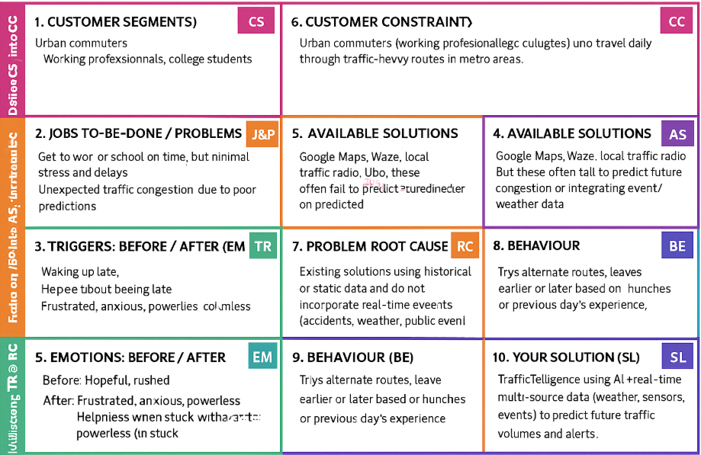
References:
- https://www.ideahackers.network/problem-solution-fit-canvas/
- https://medium.com/@epicantus/problem-solution-fit-canvas-aa3dd59cb4fe

